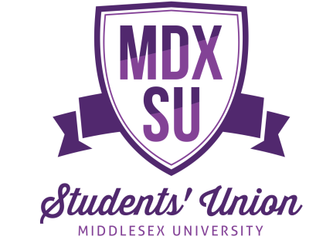
Social Media & Digital Content Intern
Information
Part-time, Fixed Term until 31st May 2021
7 hours per week (1 day or 2 half days per week)*
Location: home-based
Salary: London Living Wage of £10.75 per hour
Accountable to: Communications Coordinator

We are open to flexible working, in order to cater to students’ caring or commuting commitments. MDXSU staff are currently working remotely, and will continue to do so for the foreseeable future. All student staff roles will operate remotely, but will be fully supported and supervised by MDXSU full time staff.
*Hours to be completed Monday - Friday

The Role
We are looking for a talented and creative student who has experience of writing articles and creating social media content. The successful candidate will work closely with our Communications and Income Team to drive participation through written and digital content – promoting events, projects and the Students’ Union as a whole. You would be working to ensure students know about the opportunities and activities we offer, with a particular focus on engaging interest online with digital content and social media coverage.

Responsibilities
- Produce visual and creative content for MDXSU digital platforms to raise awareness and engagement of MDXSU activities and opportunities as part of our Communications Calendar. These include the MDXSU website, Facebook, Twitter and Instagram.

- Work with the Communications and Income Team to find and commission student-led projects and content to help drive engagement on our website and social media platforms.

- Attend events across the University and MDXSU (predominantly virtually, but in-person when such activity is possible) to create content that can be shared and disseminated from these events.

- Support the various teams and departments within MDXSU with the promotion of their projects and monitor engagement on MDXSU’s platforms, creating regular social media reports.

Requirements
Criteria | Requirement
Qualifications
Current student studying at Middlesex University | Essential
Knowledge
Online marketing and communications knowledge | Essential
Experience using digital platforms | Essential
Experience in writing and developing content for blogs and website | Essential
Experience in using Adobe Creative Suite (or equivalent) | Desirable
Attributes/skills
Excellent communication skills; written & verbal | Essential
Confident in using different social media platforms | Essential
Excellent planning, organisational & administrative skills- with a particular focus on attention to detail | Essential
IT competent with an understanding of Microsoft Office | Essential
Strong interpersonal skills | Essential
Ability to meet strict deadlines | Essential
Confident in speaking to different types of people | Desirable
Skills in graphic design and/or photography | Desirable
Skills in creating creative visual content | Desirable
Values & Ethics
Team player | Essential
Positive attitude & enthusiasm about Middlesex University & MDXSU | Essential

