Student Media Brand Survey 2021

Promotion and Data Collection
The promotion of the survey had two phases. The first was targeted only at current members of MDXSU Student Media, and the second was to all students. The survey questions were identical in both phases.
The survey was firstly sent out only to students currently registered as a member of one or more of the Student Media groups on the MDXSU website. This was promoted through emails via UnionCloud and the student leaders asking their teams to fill in the survey in their group chats. In total this led to 43 views and gathered 10 survey responses.
The survey was then sent out to all students via an email and social media campaign. A link to the survey was included in two editions of the regular MDXSU all-student newsletter and in the Societies newsletter. The survey was also promoted on MDXSU social media channels. The survey link was also sent to key contacts at the University to circulate to their student cohorts, including members of the academic staff for some media courses and the Graduate Academic Assistants for media courses. In total this led to 856 views and gathered 121 responses.
The survey was also added to the MDXSU website, using an iFrame to host the survey on a dedicated page which was accessible from the homepage. In total this had 38 views and gathered 8 responses.
The survey was incentivised with two £100 vouchers for the winner of prize draws, one for just the members of Student Media, and a second for all students. The totals from all collectors used for the survey was 937 views and 139 responses, of which 124 were completed. Approximately one third of all views and responses came in the final week of the period that the survey was open for, suggesting that the final reminder included in the SU newsletter and the emails sent out by media course GAAs were the biggest factors in gathering results.

Awareness of Student Media
Students were firstly asked if they were aware that MDXSU had a student-led media platform. 61% of students said they were aware of our student-led media platform with the other 39% saying that they were not aware.
While this is only an indicator, with a small sample size, 61% awareness is still a slight way off the Student Media Strategy 2020-22 target of 70% of Middlesex students knowing what our student media offer is. Our approach to the promotion of the survey was also weighted towards students who are more likely to be aware of our Student Media (in particular, targeting the Student Media members and then targeting students on media courses). It is also likely that students would be more likely to complete the survey if they were already aware of our Student Media. Therefore, we may be even further off this target than the survey figure of 61% suggests, so it should be a priority to develop a detailed marketing strategy as part of the Student Media Strategy.
Recommendation: Develop a detailed marketing strategy with advice and input from the MDXSU Comms and Income Team. This should focus on increasing awareness of the various platforms and developing an audience for our media platforms, as well as on recruitment of new members.

Respondents who were aware of MDXSU Student Media were asked how they found out about it in a multiple-choice question in which respondents could select as many answers as were applicable to them. The MDXSU website was the most selected answer by a significant margin, with 72% of all respondents answering that they had found information about Student Media on our website.
The second top answer was social media (31%). This suggests a significant number of students are finding out information from social media and we should continue to use social media to promote Student Media.
Recommendation: Ensure any changes made to Student Media branding and marketing are changed across the whole MDXSU website as a priority. Social media should be used frequently to direct traffic to the website for in-depth information and for members signups.
Recommendation: As part of the marketing strategy, we should develop a social media plan for Student Media which takes into consideration the various channels currently being used to promote Student Media.

Following Freshers Fair/Other fairs (23%) and events (18%). This data indicates that in-person events such as Freshers Fair are a major factor in students finding out information about Student Media, and we can make the logical assumption that these figures would have been even higher if on-campus activity had not been cancelled and disrupted by the ongoing pandemic.
Recommendation: Ensure there are on-campus events and fairs to promote Student Media opportunities to students once these are safe and practical to do so. These events should not replace online promotion, which should still take a significant role, not only due to the continuing pandemic situation but also because of our geographically spread-out student body.

All the other answers were not as frequently selected as those explained above. However, we can see from the full results below that all the methods of finding out about Student Media are viable, so can and should be continued as they are, while not necessarily being prioritised over good website and social media promotion and in-person/on-campus promotional Fairs and events.

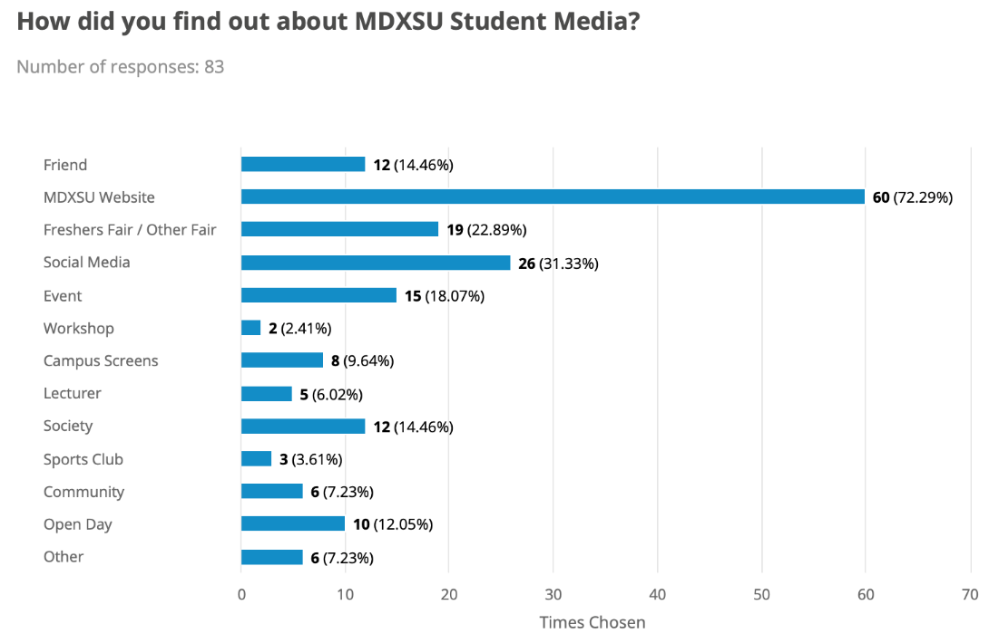

Involvement in Student Media
The next section of the survey had two pathways depending on whether respondents answered that they had been involved in Student Media activities.

Experience of Student Media
Students who answered that they had been involved were asked to rate their experience of MDXSU Student Media on a scale of 1-10. The average score given was 7.6 out of 10, suggesting there is generally a good experience within Student Media, although with room for improvement.
The data was used to create a Net Promoter Score (NPS) for MDXSU Student Media. A NPS is calculated by sorting respondents into three categories using their scores to create an approximate guess of how likely they would be to actively promote Student Media to others. The categories and their percentages in the survey are shown in the table below.
Score | Category | Percentage
0-6 | Detractors | 25%
7-8 | Passives | 46%
9-10 | Promoters | 29%

The NPS is calculated by subtracting the percentage of Detractors from the percentage of Promoters. Our NPS score is therefore 4 (29-25). Any NPS score which is a positive figure is considered good as it tends to mean that in general respondents are happy with their experience and are likely to recommend Student Media to others, which will lead to growth of members and audience. Work can be done to improve this score though, which would help Student Media grow faster over the next few years. Therefore, in order to find out how we could improve the MDXSU Student Media experience, respondents were asked to give a reason for their score in an optional open text answer. 75% of respondents included a reason for their answer.

Detractors
Some examples of reasons given for scores in the Detractor range include a lack of activity from Student Media over the past year: “I am not aware of any relevant activities that the Student Media has done in the past year, nor do they have much influence or usually reach out to the members.” (Score of 4). In another answer this lack of activity and reach across the University was linked to low membership figures and a lack of support and input from the Students’ Union: “I found it extremely enjoyable but also under supported. Generally the problem with all of them was an inability to reach across the university and recruit enough students to drive the branch forwards, and also a lack of knowledge, training and supervision from within the SU.” (Score of 6)
Other reasons for low scores were more due to personal circumstances, for example time: “I haven't interacted much with the media since being too busy with my study and assignments” (Score of 6). This was also a common reason for not being involved given by students who had not participated in Student Media, which can be seen in more detail below.

Passives
Many answers in this range emphasised the friendly and welcoming nature of the Student Media teams. Often, these answers also included an emphasis on the future potential of Student Media, with many answers suggesting that they saw Student Media developing well and were excited to be involved in the future, especially after the pandemic. This was balanced by a more critical view that the current Student Media offer is not ambitious enough and that the teams are not big enough, which was also seen in reasons for lower scores.
"I like the energy. It's been difficult but I think with the positivity of the team that's developing and the energy it's going to be good and give out a lot of energy and be inclusive. I get a lot from it as I have a lot of ideas […] I feel it's going to give me a lot as much as I put in as well.” (Score of 8)
“Most of the members are fun lively people and there’s great opportunity for potential.” (Score of 8)
“Very friendly, open and welcoming. Good Opportunity to get experience but it would be better to be more ambitious network and content-wise.” (Score of 8)
“It’s always been good being a part of student media, just unfortunate we are unable to enjoy as much as possible due to Covid.” (Score of 7)

Promoters
In the Promoter category, there were no detailed reasons given for their high scores. This does leave us with a lack of information about what aspects of Student Media are key to students who rated their experience extremely high on the scale. We should instead focus on changing and developing the aspects of Student Media that were given as reasons for lower scores and/or work with current teams to evaluate what works well and what factors keep them active in the team.

Reasons for not participating
Students who said that they have not been involved in Student Media were instead asked the factors why they had not participated in Student Media activities. This was a multiple-choice question in which respondents could select as many answers that were applicable to them.
The top reasons given from the options provided were not receiving enough communication, not having enough time alongside studying, not knowing what it involved and finding it too difficult to be involved during lockdown.
In contrast, only one person said they were uninterested in learning media skills and one other said they did not see being involved in Student Media helping their career.
Recommendation: Increase levels of communication with all MDX students about MDXSU Student Media opportunities, ensuring there is a particular focus on explaining what is involved.
Recommendation: Develop easy pathways for students to be involved with Student Media that are flexible and allow for time-poor students to be involved that fits around other their commitments including studying, working, other recreational activities and/or caring responsibilities.
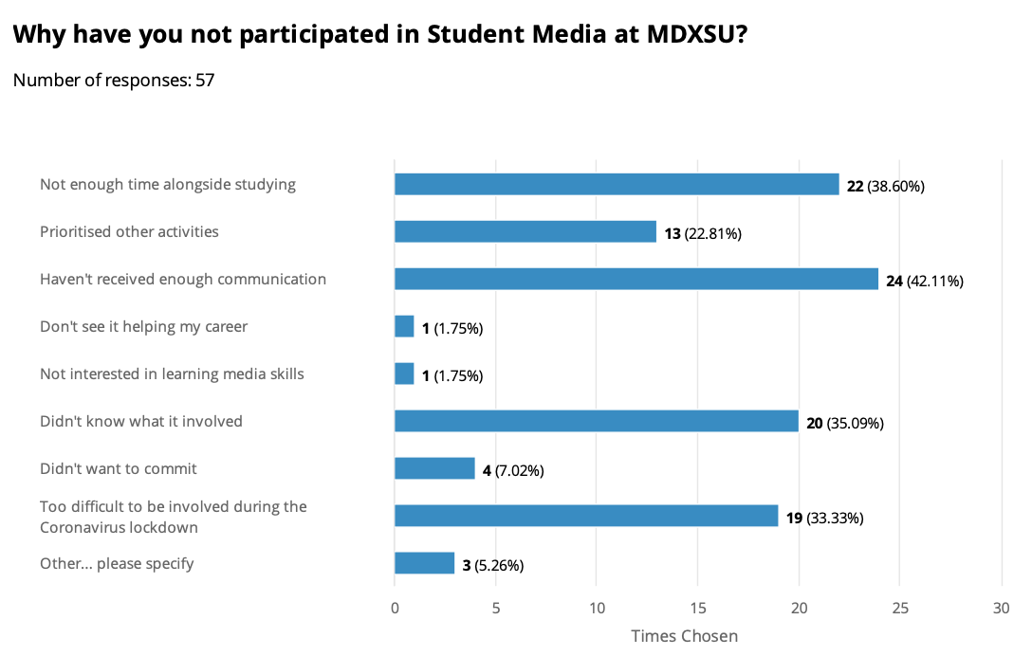

Values
Students were given a pair of values and were asked to indicate what was most important to them on a sliding scale. The value pairs and the brief definition are shown here:

Progressive (innovative and forward thinking) | Structured (focused on a fixed year calendar of activity)
Skills Focused (e.g. learn to edit videos or write articles etc.) | Experience Focused (e.g. learn as you volunteer in activities and events)
Recreational (providing basic level skills for experimental media production) | Industry Focused (providing advanced level skills for employment)
Campus Focused (providing media experience & opportunities on-campus) | Community Focused (report on the local community and news-based media)
Showcasing Talent (create spaces to showcase the work of Student Media) | Recognition & Reward Based (acquire rewards and incentives when producing media)
Collaborative (focused on student media community, collaboration and networking) | Individual (focused on individuals goals and reason for joining student media)

In general, students wanted their Student Media to be Progressive, Experience Focused, Industry Focused and Collaborative. In the case of students wanting Student Media to be Industry Focused, this was true even once the students from media course, who it can be assumed are focused on progressing into the media industry after graduation, were filtered out of the results.
The split was almost 50/50 for Campus Focused and Community Focused suggesting students want their Student Media to focus on multiple aspects of student life. The result was also close in the case of Showcasing Talent and Recognition & Reward Based, though slightly balanced towards the former, suggesting there is a diversity of motivations for getting involved in Student Media which we need to recognise moving forward to grow, develop and motivate the teams.

Branding and Promotion
Students were given a series of statements and asked to select the statements that they agreed with. Although presented as three pairs of opposing statements, respondents were able to select as many answers as they wanted to from the list given. This meant that if they had an opinion on some but not all of the branding questions they could still answer and provide useful information.
The statements all related to the name(s) and brand(s) of the MDXSU Student Media platforms. The list of statements and the number of times they were selected are shown below:
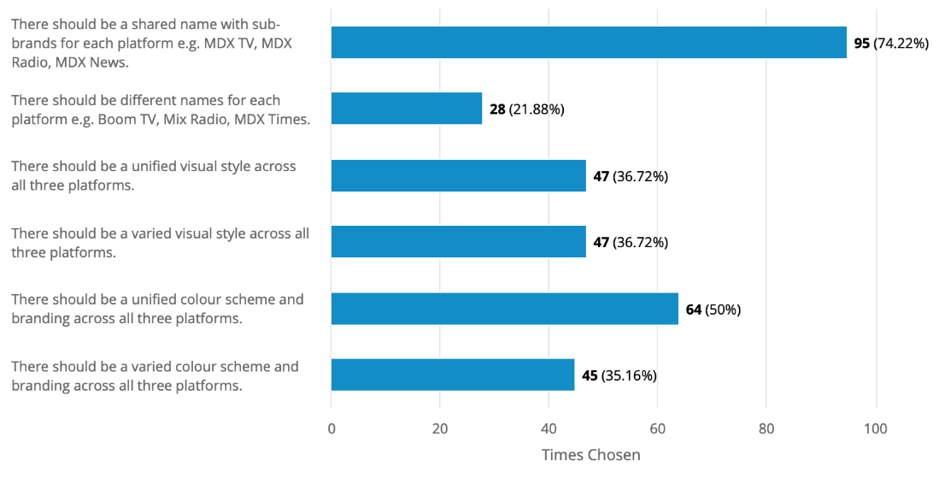
When viewed as pairs of opposing statements, we can see that there is a clear trend towards wanting a shared name for Student Media with sub-brands for the platforms, with 74% of respondents indicating that they agreed with this statement compared to 22% in favour of entirely different names.
The statements relating to the visual styles and colour schemes of the platforms are far less conclusive. In the case of the two statements about visual styles there was a completely even split, with 37% of respondents agreeing that there should be a unified visual style and 37% of respondents agreeing that there should be a varied visual style.
Recommendation: Create one MDXSU Student Media brand name and change the names of some, or all, of the current Student Media platforms (MDXFM, Student Media TV, The Echo) to bring them all under the unified brand name.

Suggested names
Respondents were asked to suggest names for the three platforms (Radio, TV, Newspaper/Magazine) in an optional, free text question.
TV Platform
48 respondents (37%) suggested names for the TV Platform. 31 of the 48 answers (65%) included the letters ‘MDX’ in the suggested platform name, and one other suggested ‘Middlesex TV’. ‘MDX TV’ was the most common individual answer to the question.
Radio Platform
47 respondents (38%) suggested names for the Radio Platform. 27 of the 47 answers (57%) included the letters ‘MDX’ in the suggested platform name. Another said that the ‘current name [MDX FM] is perfect’. ‘MDX Radio’ was the most common individual answer to the question, followed by ‘MDX FM’.
Newspaper/Magazine/Blog Platform
45 respondents (36%) suggested names for the Newspaper/Magazine/Blog Platform. 24 of the 45 (53%) answers included the letters ‘MDX’ in the suggested platform name or suggested including the University name. Unlike the other two platforms, there was more variation in the full suggested names. These include ‘MDX Echo’, ‘MDX Times’, ‘MDX Magazine’, MDX Gazette’, ‘MDX News’ and more.
Recommendation: As part of bringing all platforms under one brand, change the name of the TV platform to ‘MDX TV’ and leave the Radio platform with its current name of ‘MDX FM’. The Newspaper platform should also contain the ‘MDX’ initials, and we should work with current student media team members, the SU Comms Team and the Sabbatical officers to finalise the new name.

Newspaper/Magazine/Blog Platform
Students were asked what kind of publication they would want to read, and what they would want to write or produce content for. This was a multiple-choice question in which they could select as many answers as they felt were applicable. There is a clear trend in both questions that a digital publication would be the preferred option, and this matches wider media consumption trends.
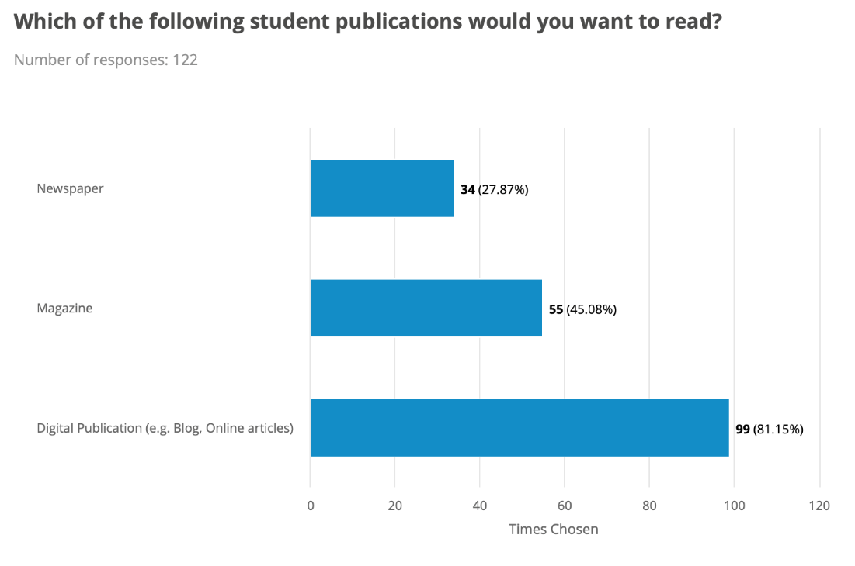
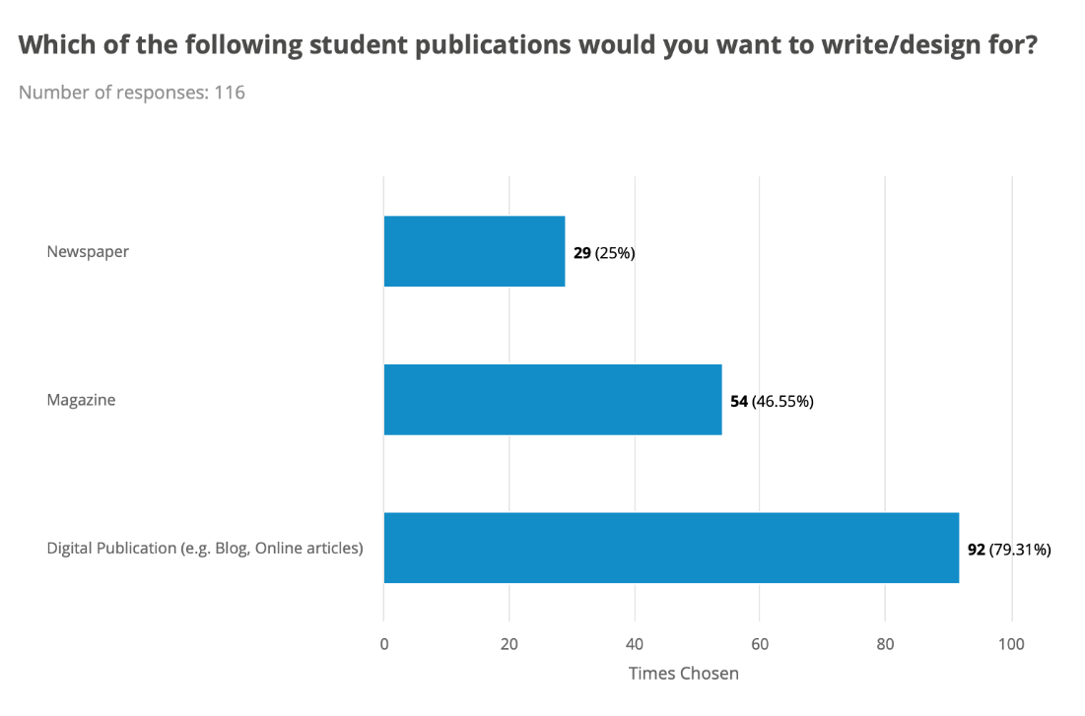
Recommendation: Invest more resource into developing the digital side of the Newspaper platform through increasing the number of published articles and building the audience among the MDX student body. If/when we publish in a physical format this should be in a magazine format and should have a detailed marketing plan to ensure success upon relaunch.

Final Comments
Finally, students were asked an open text question for any other comments on how Student Media could be improved. This was answered by 57 students and can be grouped predominantly into the following themes:

Promotion
By far the most common answer to this question were comments related to the need to promote Student Media more among the student body. Several students mentioned that they had never heard of Student Media before this survey, however they also tended to say that they would be keen to be involved if they were made more aware of opportunities available to them. For example:
“Promotion among students - I don't know anything about them. To be fair, covid made the campus inaccessible however, all the more reason to reach out and adapt to new ways”.
“There should be more promotion on other MDX platforms. Any student-related content should be displayed here. It should be the go-to source for student content”.
Many answers to this question related to this theme also gave useful information about how to go about promotion which should be revisited as part of the development of the marketing plan, for example:
“There should be more events or activities to allow students to know what's going on. I didn't hear much about the MDXSU student media over my time at the university. Perhaps play the radio station through the campus or in MDX house, just so that students can enjoy listening to other students on the radio. Have magazines or adjust the MDX App to have a section for the writing pieces, and have the TV section of MDXSU student media to be displayed on TV's around campus. TV's on-campus play the same video, which gets boring over time, so having maybe intervals throughout the day where the tv sections on the MDXSU student media can play would be fun as more students can enjoy seeing it and will hear more about MDXSU student media. I would recommend not sending out too many emails, as students receive so many emails they just ignore the ones that aren't about their studies etc. Creating word of mouth would be better, and reassuring students that they don't have to study film, tv etc to join”.
Recommendation: Work with Middlesex University staff to explore and, if possible, implement outreach and marketing opportunities, including playing student radio station in University buildings and including links to Student Media in the MDX App.

Employability
Another emphasis was on the need to focus on student futures and employability. These answers included an emphasis on ensuring that Student Media offered a broad range of skills development opportunities and training that focused not just on the practical skills involved with media activity (e.g. video editing, podcast production) but also on so called ‘soft skills’ such as leadership, teamwork and project management. Some example answers that summarise this theme are:
“Maybe the platforms could be used more to talk about the future, eg research that needs to be done and ways that students can get awards or prizes. Competitions alongside courses would be good to promote and will help students diversify their CVs and experience”
“It also needs to help students after university. As I was doing a film degree, the idea of learning skills through the TV channel was quite unimpressive as I'm already learning that. I felt that there wouldn't be much taught that I didn't already know. The focus should be on giving students a platform where they can take the skills they've learnt through their degree and do something more noteworthy with them that will look good for CVs and employers”.
Recommendation: Work with academic staff from media courses to develop pathways for students to use skills learned in their studies in practice with MDXSU Student Media.

Content
Finally, there were some answers about the need to create and publish more content. This answer was also regularly linked to the need to promote the platforms further throughout the University. However, this theme was summarised in one short, snappy comment: “Post more content”!

Summary of Recommendations

Develop a detailed marketing strategy with advice and input from the MDXSU Comms and Income Team. This should focus on increasing awareness of the various platforms and developing an audience for our media platforms, as well as on recruitment of new members.
Ensure any changes made to Student Media branding and marketing are changed across the whole MDXSU website as a priority. Social media should be used frequently to direct traffic to the website for in-depth information and for members signups.
As part of the marketing strategy, we should develop a social media plan for Student Media which takes into consideration the various channels currently being used to promote Student Media.
Ensure there are on-campus events and fairs to promote Student Media opportunities to students once these are safe and practical to do so. These events should not replace online promotion, which should still take a significant role, not only due to the continuing pandemic situation but also because of our geographically spread-out student body.
Increase levels of communication with all MDX students about MDXSU Student Media opportunities, ensuring there is a particular focus on explaining what is involved.
Develop easy pathways for students to be involved with Student Media that are flexible and allow for time-poor students to be involved that fits around other their commitments including studying, working, other recreational activities and/or caring responsibilities.
Create one MDXSU Student Media brand name and change the names of some, or all, of the current Student Media platforms (MDXFM, Student Media TV, The Echo) to bring them all under the unified brand name.
As part of bringing all platforms under one brand, change the name of the TV platform to ‘MDX TV’ and leave the Radio platform with its current name of ‘MDX FM’. The Newspaper platform should also contain the ‘MDX’ initials, and we should work with current student media team members, the SU Comms Team and the Sabbatical officers to finalise the new name.
Invest more resource into developing the digital side of the Newspaper platform through increasing the number of published articles and building the audience among the MDX student body. If/when we publish in a physical format this should be in a magazine format and should have a detailed marketing plan to ensure success upon relaunch.
Work with Middlesex University staff to explore and, if possible, implement outreach and marketing opportunities, including playing student radio station in University buildings and including links to Student Media in the MDX App.
Work with academic staff from media courses to develop pathways for students to use skills learned in their studies in practice with MDXSU Student Media.

